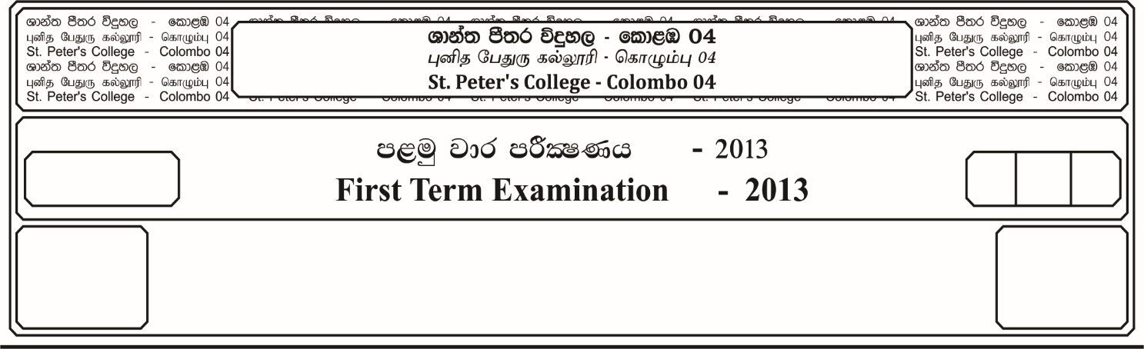

13 fY%aKsh

GRADE 13

E

meh

Hour

I

**m<uq jk jdr mÍCIKh - 2024**

**First Term Examination - 2024**

ixhqla; .Ks;h - ¸

**COMBINED MATHEMATICS – I**

10

$$03$$

* **Answer all the questions from Part A and only five questions from Part B.**

**Part A**

01. Prove by the mathematical induction, that $2 (4)^{2n+1} +3^{3n+1}$ is divisible by for .

02. Solve the equation

03. Solve the inequality for **,**

04. Determine the ratio in which the line $3x+y-9=0$ divides the segment joining the points and

05. Show that,

06. If then show that,

07. If  then prove that,

08. Find the equation of the line passing through the intersection of the lines $3x-4y+1=0$ and $5x+y-1=0$,cutting of equal intercepts on the coordinate axes.

09. Show that,

10. Find the area bounded by line $x=4$, $x$ and $y$ axis, and the curve .

**Part B**

11. a). If  **,**  are the roots of the quadratic equation ${ax}^{2}+bx+c=0$ , where , $b$ and $c$ are real constants. Find expressions for $∝_{1}$ **+ $∝_{2}$**  and $∝_{1} ∝_{2}$ in terms of , $b$ and $c$.

Let $∝$ and $β$ be the roots of the equation $x^{2}+2λx+2λ+15=0$, where $λ$ is a real constant.

i). Find the set of values of $λ$ for which $∝$ and $β$ are real.

ii). Obtain an equation of the from $y^{2}+qy+r=0$, whose roots are $2∝ + ∝β$ and $+ ∝β$, expressing the constants $q$ and $r$ in terms of $λ$.

b). When the polynomial $P\left(x\right)= {ax}^{3}+ {bx}^{2}+3x-1$ is divided by $(x-1)$, the remainder is $2$. When it is divided by $(x+1)$, the remainder is $3$. Find $a$ and $b$. Find the remainder when $P(x)$ is divided by .

12. a). Express in partial fractions,

$${ \atop (1- x^{2})}$$

$\frac{2x -1}{(2 + x)}$

b). If $a$ and $b$ are two positive numbers then show that $\frac{a+b}{2}$ $≥ \sqrt{ab}$.

If $a$, $b$ and $c$ are positive numbers, prove that $(a+b)$ $(b+c)$ $(c+a)$ $≥8 abc$.

c). Sketch, in the same figure, the graphs of $y=|2x-1|$ and $y=\left| x \right|+$ $\frac{5}{3}$.

Hence or otherwise find the set of values of $x$ for which,

.

13. a). is a triangle and the equations of the sides $AB$, $BC$ and $CA$ are $x-2y+2=0$, $x-y-1=0$ and $2x-y-1=0$. Two lines perpendicular to $BC$ and passing through $A$ and another line passing through $B$ and parallel to $AC$ intersect at the point $D$.

i). Find the equations of the lines $AD$ and $BD$.

ii). Show that $ABDC$ is a rhombus.

b). Find the equation of the acute angle bisector of the lines and

14. a). Let for $x ≠0$, $-6$

Show that $f^{1}(x)$, the derivative of $f(x)$, is given by $f^{1}\left(x\right)=$ $\frac{-3 \left(x+2\right) (x-6)}{x^{2} (x+6)^{2}}$

for $x ≠0$, $-6$

Hence, find intervals on which $f(x)$ is increasing and the intervals on which $f(x)$ is decreasing.

Sketch the graph of $y=f(x)$ indicating the asymptotes, $x-$ intercept and the turning points.

b). Show that the maximum volume of $a$ cylinder that can be contained in a cone of height $h$ and radius $a$, such that their axes coincide is .

15. a). Integrate, $\int{\frac{x + 7}{x + 9}}$ $dx$

b). Show that $\int_{0}^{1}{\frac{dx}{\left(1 + x\right) (1 + x^{2})}}$ $=$ $\frac{π}{8}$ $+$ $\frac{1}{4}$ $ln2$

c). Using integration by parts, find $\int{x^{2} cos2x dx}$

d). Using the substitution $x-3={2Sin}^{2} θ$ for $0≤ θ ≤$ $π/4$

Evaluate,

16. a). Given that $Sin \left(A+B\right)=Sin A . Cos B+Cos A . Sin B$

Hence show that,

$\tan{(A-B)}=$ $\frac{tan A - \tan{B}}{1 + \tan{A} . tan B}$

b). Let $ABC$ be a triangle. In the usual notation, using the result $A+B+C= π$

Show that,

i). $Sin$ $\left(\frac{B + C}{2}\right)$ $=Cos A/2$

ii). $tan$ $\frac{A}{2}$ $.$ $tan$ $\frac{B}{2}$ $+$ $tan$ $\frac{B}{2}$ $.$ $tan$ $\frac{C}{2}$ $+$ $tan$ $\frac{C}{2}$ $.$ $tan$ $\frac{A}{2}$ $=1$

c). Find the general solution of the equation,

$Cos2θ=$ $\left(\sqrt{2} + 1\right)$ $(Cos θ-$ $\frac{1}{\sqrt{2}}$ $)$

d). Solve the equation,

$\tan^{-1} \left(x +1\right)+ 2 \tan^{-1} x = π/2$